# Coupling Mechanisms

## Conditions

Axial force:

Force sensor meter thing?



Base force = 1250N

Safety factor = 2→Force = 2500N

Safety factor = 4→Force = 5000N

Zero based

## 

Yaw N = 6.28 rad/s → safety factor = 4 → 26 rad/s

Pitch N= 4.189 rad/s → safety factor = 4 → 17 rad/s

Material for fatigue data: gray cast iron. Solidworks doesn’t have fatigue data for 1060 aluminum. I used the weakest material I could find to be safe.

## Lever Lock

Between two thicknesses, 0.4”(0.51lb) vs 0.5” (0.63lb).

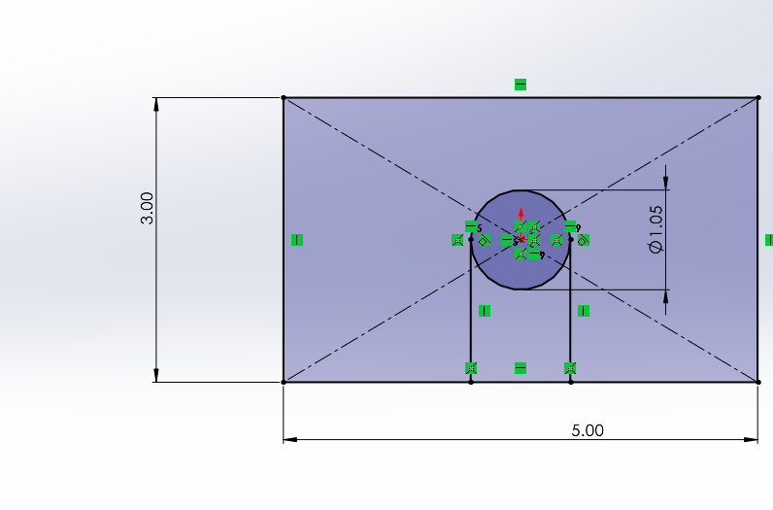

### Static Axial

*Lever lock should not ever actually see this much force. Oscillating collision is a bigger concern but this was kind of a way to gauge it.

| Test | Result (T = 0.4”) | Result (T = 0.5”) |
| --- | --- | --- |
| F=5000N  Safety = 4 |  |  |
| F=2500N  Safety = 2 |  |  |

Conclusions:

* Both are passable in terms of the forces it will be subjected to.
* 0.5” thickness suffers only half the displacement compared to 0.4”. If this is machinable it will be a better choice long term.

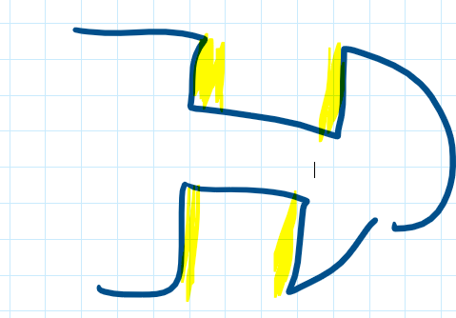

### Static Centrifugal

| Test | Result (Safety = 4, T=0.5”) |
| --- | --- |
| N = 17/s |  |
| N=26/s |  |

### Fatigue Axial

| Test | Result (T = 0.5”, Safety =4, F=5000N) | Result (T = 0.5”, Safety =2, F=2500N) |
| --- | --- | --- |
| N=60,000 |  |  |

### Fatigue Centrifugal - Incomplete

| Test | Result (T = 0.5”, Safety =4) |
| --- | --- |
| Both pitch and yaw |  |
| F=2500N  Safety = 2 |  |

### 

## Funnel

### Static Axial

| Test | Result |
| --- | --- |
| F=5000N  Safety = 4 |  |
| F=2500N  Safety = 2 |  |

### Static Centrifugal

| Test | Result |
| --- | --- |
| Pitch  N=17/s |  |
| Yaw  N=26/s |  |

### Fatigue Axial

| Test | Result |
| --- | --- |
| N=60,000  F=5000N |  |

### Fatigue Centrifugal - Incomplete

## Male

### Static Axial

| Test | Result |
| --- | --- |
| F=5000N |  |
| F=2500N |  |

### Static Centrifugal

| Test | Result |
| --- | --- |
| Yaw  N=26/s |  |
| Pitch  N=17/s |  |

### Fatigue Axial

| Test | Result |
| --- | --- |
| N=60000  F=5000N |  |
| N=60000  F=2500N |  |

### Fatigue Centrifugal - Incomplete

# Mounting

## Conditions

Weight of coupling system: 10 kg

10 kg * 10=100N

Current total mounting length: 24” (arbitrarily chosen) → 0.61m

Overhang length = 12.96” → 0.33m.

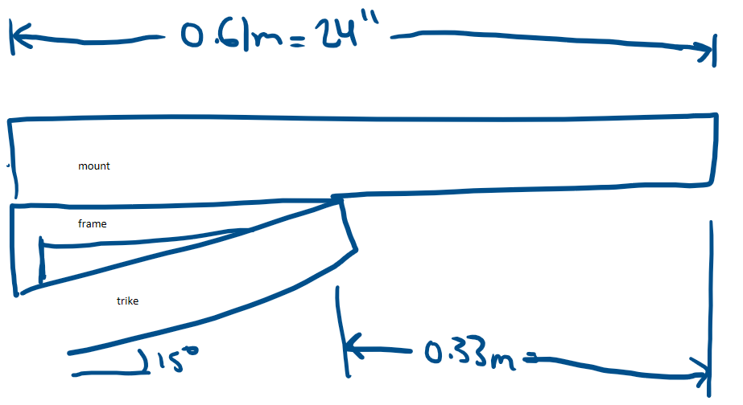

## Screenshots

| Front end support frame |  |
| --- | --- |
| Front end support frame |  |
| Front end support frame + mounting |  |
| Front end support frame + mounting |  |
| Front end support frame + mounting + coupling mechanism |  |
|  |  |
| Front end support frame + mounting + coupling mechanism + trike |  |
| Front end support frame + mounting + coupling mechanism + 2 trikes |  |

What I need:

* U-joint dimensions
* Better pictures of the trikes
* Trike dimensions

Design drivers:

* Distance between vehicles
* Weight (can bike rack support?)
* How to fabricate?

Strain gauge?

P=VI=Fv